Python Programming

Experiment Report

Name DIO STANIA ADINATA
Student Number
Major Software Engineering
Class 2023

2022

Experiment 5

- Experimental Purpose
Experiment 2 aims to deepen the understanding of Python programming through the following objectives:
  - Understand how to use comparison operators and Boolean expressions to evaluate conditions.
  - Performing basic selection structures by using if, if-else, and if-elif-else statements to control program flow based on conditions.
- Experiment Content
  - Objective1: Determine if an Integer is Less Than 100
    - Design thought
I plan to create a Python program that asks the user to input an integer. Then it will evaluates whether the integer is less than 100 or not by using the "<" operator. The result of this comparison is a Boolean value (True or False), the result will printed directly.
    - Source Code
num = int(input("Enter an integer: ")) result = num < 100
print("Is the integer less than 100?", result)
    - Experiment Result

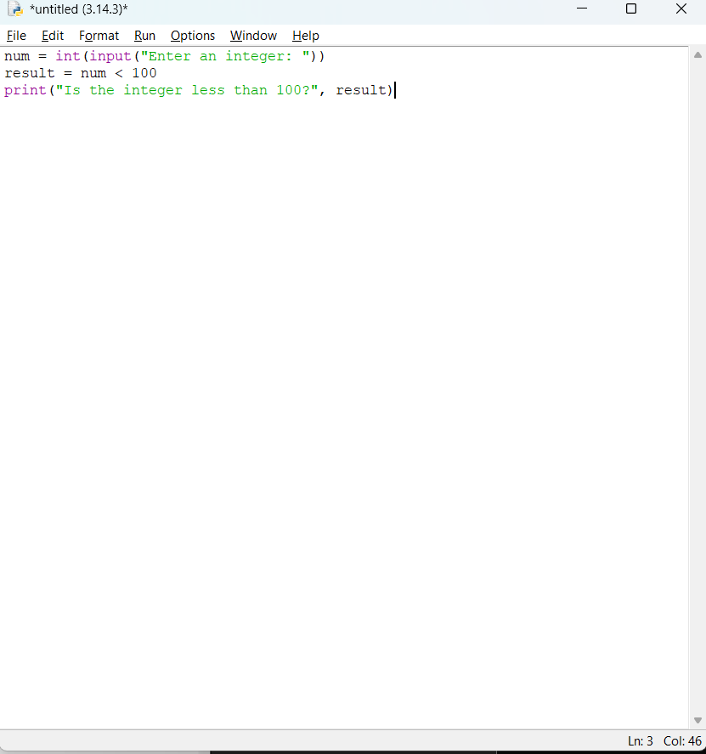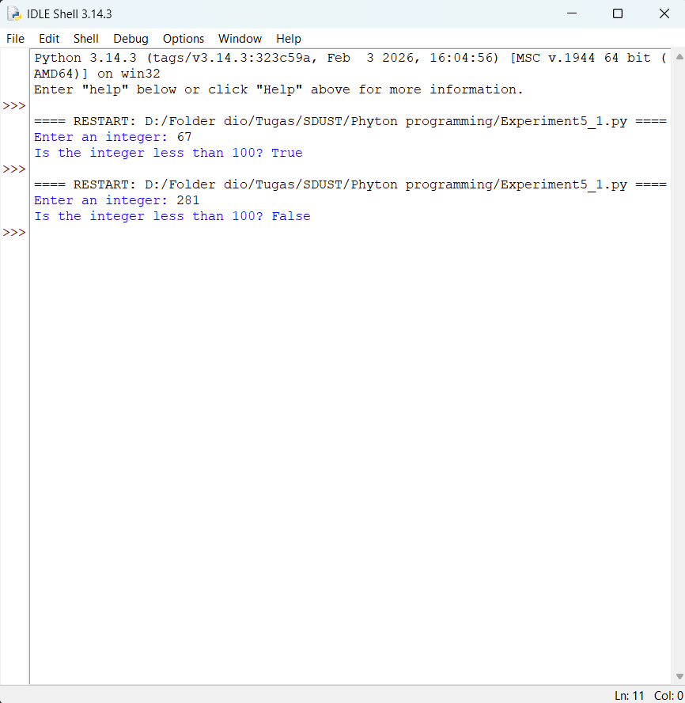

  - Objective2: if Statement with Variable Assignment
    - Design thought
I plan to create a program that checks the value of a variable x. If x is greater than 100, it assigns 20 to variable y and 40 to variable z. If the condition is false, y and z can retain default values or remain undefined. The program demonstrates the use of a simple if statement without an else clause.
    - Source Code
x = int(input("Enter a value for x: "))

if x > 100:
y = 20
z = 40
print(f"Since x = {x} is greater than 100, y = {y} and z = {z}") else:
print(f"x = {x} is not greater than 100, no assignment was made.")
    - Experiment Result
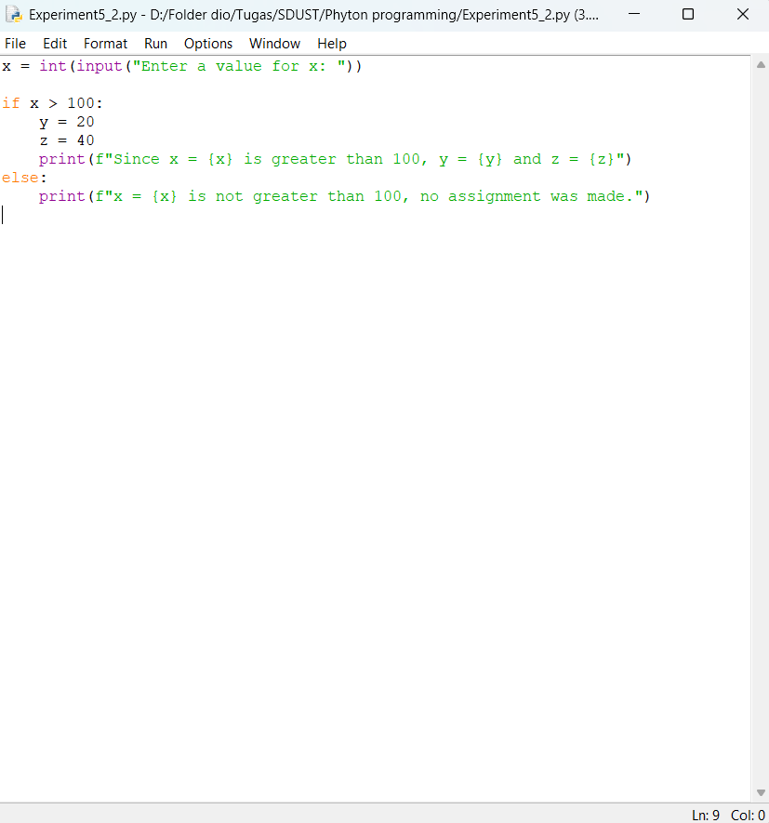

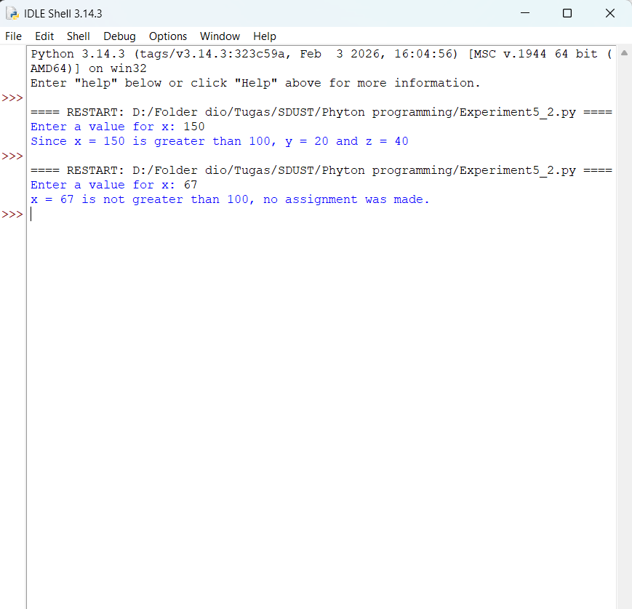

  - Objective3: Delivery Fee Calculation Based on Package Weight
    - Design thought
I plan to create a program that asks the user to input the package weight in kilograms. And by using an if-elif-else structure, the program will checks the weight against the given ranges:
- Weight ≤ 1 kg → fee = 10 RMB
- 1 kg < weight ≤ 3 kg → fee = 20 RMB
- 3 kg < weight ≤ 5 kg → fee = 30 RMB
- Weight > 5 kg → print a message asking the user to go to the mail company.

    - Source Code
weight = float(input("Enter package weight (in kg): "))

if weight <= 1: fee = 10

print(f"Delivery fee: {fee} RMB") elif weight <= 3:
fee = 20
print(f"Delivery fee: {fee} RMB") elif weight <= 5:
fee = 30
print(f"Delivery fee: {fee} RMB") else:
print("Please head to the mail company and we will calculate the delivery fee for you.")
    - Experiment Result
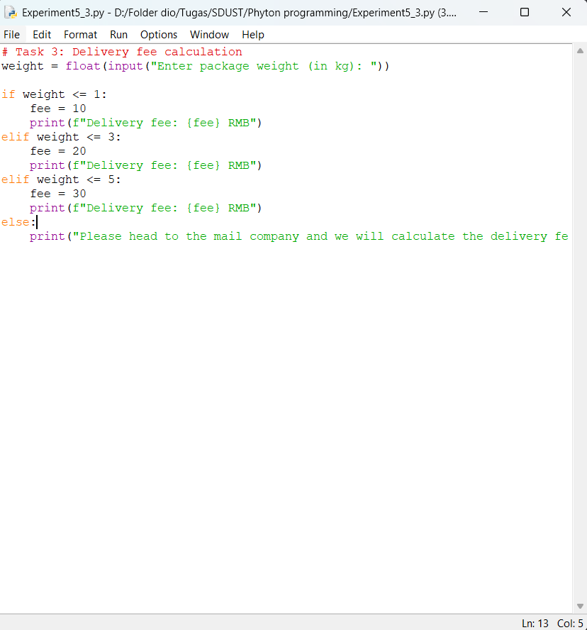

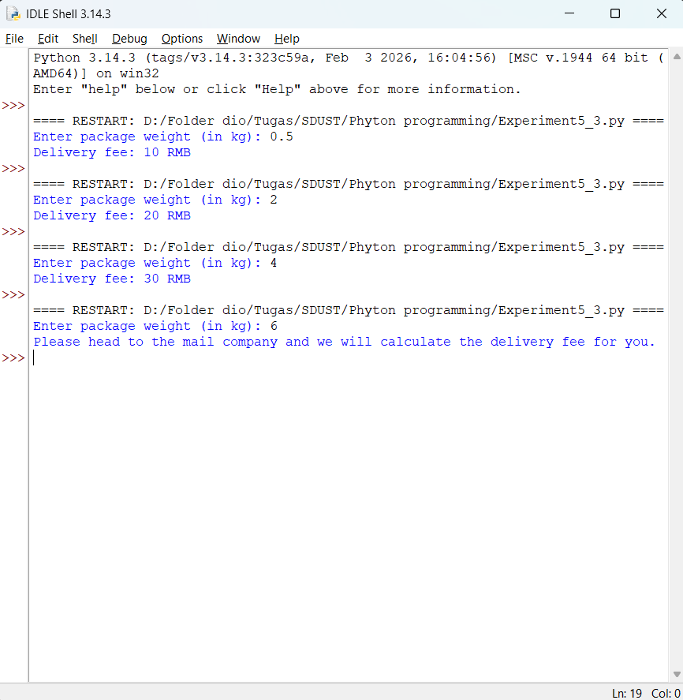

- Experiment Conclusion
What did you learn from the experiment?
From this experiment I learned several important concepts in Python programming. I learned how to condition expressions and selection structures in Python. I learn on how to writing Boolean expressions using comparison operators like “<” and “>” to evaluate conditions, and learned how to print the resulting True or False values. I also understood how to use a basic if statement to assign variables only when a certain condition is met. With if-elif-else structure I can make the program to handle multiple conditional branches.

